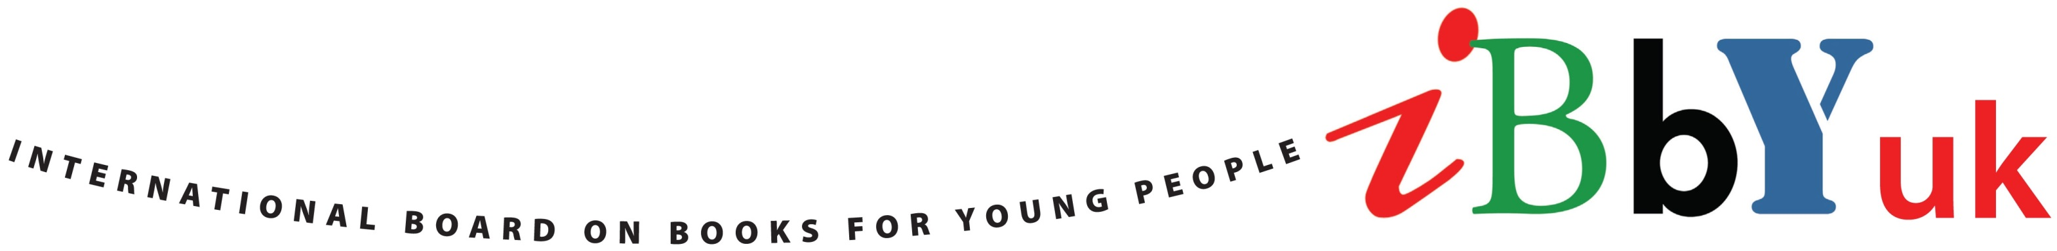

UK Nominations for IBBY’s List of Outstanding Books
for Young People with Disabilities 2017

Outstanding Books for Young People with Disabilities 2017

Every two years, IBBY invites nominations for its international list of Outstanding Books for Young People with Disabilities. Nominations are made by IBBY national sections and the final list is selected from these by the IBBY Documentation Centre of Books for Young People with Disabilities which is based in Toronto. Because of its international content, the list is unique in the children’s book world.

The books in the final selection form three collections. One is held at the IBBY Documentation Centre in Toronto and the others are available as travelling collections. An annotated printed catalogue of the final selection is published. Further details and copies of previous lists can be viewed at http://www.ibby.org/?id=271
The 2017 list will be unveiled at the Bologna Children’s Book Fair next spring.

Criteria for nomination and IBBY UK nominations for the 2017 list

The final list includes not only books that are intended for use by young people with disabilities but also books that depict young people with disabilities. There are three categories under which nominations can be made:

Category 1
Books produced in special formats, such as Braille, sign language, PCS or Bliss symbols, tactile, and easy-to-read books, specifically written for young people with developmental, mental or language disabilities; published in 2012 or later.

Category 2
Picture books from the regular production especially selected for young people with disabilities that also answer their particular needs through design, topics, illustrations and texts; published in 2012 or later.

Category 3
Picture books and novels from the regular children's book production that portray persons with disabilities; published in 2012 or later.

The IBBY UK’s nominations this year were selected by a working party whose members were Clive Barnes, Dr Rebecca Butler, Suzanne Curley and Carol Thompson, with advice from inclusion consultant Alex Strick. There were a heartening number of books available for consideration, particularly in Category 3, many of these being books for young adults. The choice in Category 1 and 2 was more limited. Over 40 books were considered by the working party and 23 were nominated. These (and the categories in which they are nominated) are listed overleaf.

IBBY UK Nominations for the 2017 list

Category

Beck, Ian Grey Island, Red Boat Barrington Stoke 1/2
Bell, Cece El Deafo Amulet (USA) 3
Booth, Anne Girl with a White Dog Catnip 3
Bourne, Holly Am I Normal Yet? Usborne 3
Bowler, Tim Game Changer Oxford 3
Brahmachari, Sita Car Wash Wish Barrington Stoke 3
Cocoretto Getting Ready Childs Play 2
Cocoretto Off to the Beach Childs Play 2
Crossan, Sarah One Bloomsbury 3
Curtis, Vanessa Baking Life of Amelie Day Curious Fox 3
Day, Susie Pea’s Book of Holidays Random House 3
DK Braille Counting Dorling Kindersley 1
DK Braille It Can’t be True Dorling Kindersley 1
Dodd, Amber Lee We Are Giants Quercus 3
Donaldson, Julia What the Jackdaw Saw Macmillan 3
Hoffman, Mary Great Big Book of Feelings Frances Lincoln 3
Hood, Kim Finding a Voice O'Brien Press 3
Kalu, Pete Silent Striker Hope Road 3
Lewis, Gill Scarlet Ibis Oxford 3
McGovern, Cammie Amy and Matthew Macmillan 3
Merino, Gemma The Crocodile Who Didn't
Like Water Macmillan 2
Rand, Ann What Can I Be Princeton
Architectural Press 2
Wilson, Jackie Katy Penguin 3

Touring the international list in the UK

An exhibition of the books on the 2015 international Disability List toured several venues in the UK earlier this year, visiting The Story Museum, Oxford; The Hive, Worcester; Seven Stories, Newcastle; and Brighton University School of Education. It is planned to tour the 2017 collection in the UK in 2018. If your institution would like a visit from the exhibition, please contact IBBY Committee Treasurer, Sue Mansfield e-mail: mansfield37@btinternet.com

